Cloud Security: Intrusion Detection System Using Federated Learning

B. Pranathi, T. Joshika , C. Krishna Kowshik
Under the Guidance of Dr. S.Ravi Kumar, M.Tech, Ph.D
Department of Computer Science and Engineering
Srinivasa Ramanujan Institute of Technology, Ananthapuramu, India
ravikumar.cse@srit.ac.in, , 224g1a0571@srit.ac.in, 234g5a0504@srit.ac.in, 224g1a0538@srit.ac.in

Keywords: Federated Learning, Intrusion Detection System, Cybersecurity, Privacy-Preserving AI, Distributed Machine Learning, Secure Model Aggregation, Network Security, Anomaly Detection, Data Privacy, Cloud Security

Abstract—
Intrusion Detection Systems (IDS) play a crucial role in safeguarding digital infrastructure, protecting sensitive data, and ensuring cybersecurity across diverse organizations. However, in many enterprises, government agencies, and distributed networks, intrusion detection information is either siloed, poorly maintained, or limited to local datasets. Traditional IDS approaches rely on centralized data collection, which raises concerns about privacy, scalability, and vulnerability to single points of failure. Although machine learning offers modern solutions for anomaly detection, most existing implementations depend on centralized training models that require raw data sharing, leading to data misuse and security risks.
This paper presents FedIDS: Federated Learning-Based Intrusion Detection System, a secure, privacy- preserving platform designed to collaboratively train intrusion detection models across multiple organizations without exposing raw data. Each participating node trains locally on its own dataset, and only model updates are shared with the central aggregator. The proposed solution ensures data confidentiality, enhances detection accuracy through diverse data sources, supports scalability across heterogeneous environments, and promotes collaborative cybersecurity in a secure and user-friendly manner.
Index Terms—Federated Learning, Intrusion Detection System, Privacy-Preserving AI, Cybersecurity Collaboration, Distributed Machine Learning, Secure Model Aggregation

I. INTRODUCTION
Intrusion Detection Systems (IDS) are essential cybersecurity mechanisms that play a vital role in protecting modern digital infrastructures. They are responsible for monitoring network traffic, detecting malicious activities, and preventing unauthorized access to sensitive data. In today’s interconnected environment, where cloud computing, Internet of Things (IoT), and distributed systems are widely adopted, IDS has become a critical component for ensuring data confidentiality, integrity, and availability. Organizations such as enterprises, government agencies, and academic institutions rely heavily on IDS to safeguard critical resources, maintain compliance, and support secure digital operations.
However, traditional IDS approaches face several challenges. Most existing systems depend on centralized data collection and processing, which introduces scalability limitations and creates single points of failure. Additionally, intrusion-related data is often fragmented across multiple systems, making it difficult to analyze and detect complex attack patterns. Manual log analysis and rule-based detection techniques are time-consuming, error-prone, and ineffective against advanced and evolving cyber threats such as zero-day attacks and distributed denial-of-service (DDoS) attacks.
Although machine learning-based IDS solutions have improved detection accuracy, many implementations still

rely on centralized training models that require sharing raw data. This raises serious privacy concerns, including unauthorized data exposure, data misuse, and lack of control over sensitive information. As cyber threats continue to grow in complexity, there is a need for a more secure, scalable, and privacy-preserving approach to intrusion detection.
Federated learning has recently emerged as an effective solution to address these challenges. It enables multiple organizations to collaboratively train machine learning models without sharing raw data. Each participant trains a local model using its own dataset and shares only encrypted model updates with a central server. This decentralized approach preserves data privacy while improving model performance through collaborative learning.
To address the limitations of traditional systems, this paper proposes a Federated Learning-Based Intrusion Detection System (FedIDS). The proposed system enhances detection accuracy, ensures data confidentiality, and supports scalable cybersecurity solutions. It also enables real-time monitoring, anomaly detection, and secure communication, making it suitable for large-scale distributed environments.
II. PROBLEM STATEMENT AND OBJECTIVES
Traditional intrusion detection systems suffer from several limitations related to privacy, scalability, and efficiency. Centralized IDS architectures require organizations to share sensitive data, which increases the risk of data breaches and unauthorized access. Additionally, these systems struggle to handle large-scale distributed environments effectively, leading to reduced performance and delayed detection.Manual monitoring and log analysis are inefficient and prone to human errors, making it difficult to manage increasing volumes of network data. Furthermore, the lack of collaboration between organizations limits the ability to detect emerging threats and attack patterns.
The primary objectives of this project are:
• To design a secure federated learning-based intrusion detection system
• To ensure privacy-preserving collaboration without sharing raw data
• To improve detection accuracy using distributed datasets
• To develop a scalable system for large network environments
• To enable real-time monitoring and anomaly detection
• To reduce risks associated with centralized data storage
III. LITERATURE REVIEW
Various studies have explored intrusion detection systems using traditional and machine learning approaches. Signature-based IDS techniques are effective in detecting known attacks but fail to identify new or unknown threats. Anomaly-based IDS methods improve detection by identifying unusual patterns but often suffer from high false-positive rates.
Machine learning-based IDS models, including decision trees, support vector machines, and neural networks, have shown improved performance in detecting complex attack patterns. However, these models rely on centralized datasets, which raises privacy and security concerns.
Recent research has introduced federated learning as a privacy-preserving approach for distributed model training. It allows multiple participants to collaborate without sharing sensitive data. Some studies have applied federated learning to cybersecurity applications, demonstrating improved detection accuracy and data protection.
However, existing solutions lack proper integration with real-world IDS systems and fail to address challenges such as communication overhead, scalability, and secure aggregation. Therefore, there is a need for a comprehensive solution that combines federated learning with intrusion detection systems.
IV. PROPOSED SYSTEM
The proposed system is a Federated Learning-Based Intrusion Detection System designed for distributed environments. It enables organizations to collaboratively train intrusion detection models while preserving data privacy.
The system consists of three main layers:
• Local IDS Layer:
Handles data collection, preprocessing, and local model training. Each node analyzes network traffic and detects anomalies using machine learning techniques.
• Federated Aggregation Layer:
Collects encrypted model updates from local nodes and aggregates them to create a global model. This process ensures that no raw data is shared.
• Backend Security Layer:
Provides authentication, secure storage, and access control mechanisms to ensure system security.• Secure communication using encryption protocols
• Role-based access control for administrators
• Real-time alert generation for detected threats
• Continuous model updates for improved accuracy
• Support for heterogeneous network environments
V. SYSTEM ARCHITECTURE AND WORKFLOW
The system architecture enables secure communication between local IDS nodes and the central aggregation server. Each node independently collects data, trains a model, and shares encrypted updates.
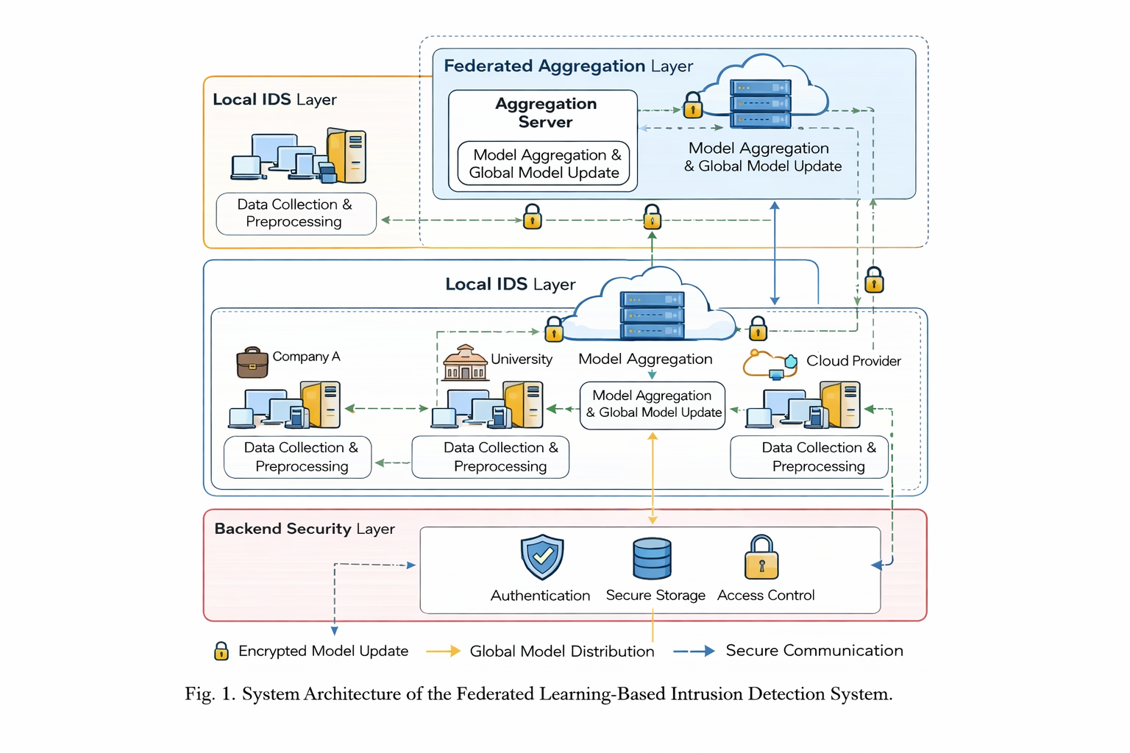
The workflow includes:
- Data collection from network traffic
- Preprocessing and feature extraction
- Local model training
- Encryption of model updates
- Transmission to aggregation server
- Model aggregation and global update
- Distribution of updated model
As shown in Fig. 1, the system consists of local IDS nodes, an aggregation server, and a backend security layer.
VI. RESULTS AND DISCUSSION
The proposed system demonstrates improved performance compared to traditional IDS approaches. By eliminating centralized data sharing, it significantly reduces privacy risks and enhances data security.
The system achieves higher detection accuracy by utilizing diverse datasets from multiple nodes. It also provides better scalability and can handle large network environments effectively.
• Reduced false-positive rates
• Faster detection of anomalies
• Improved system efficiency
• Enhanced collaboration between organizations
VII. CONCLUSION AND FUTURE WORK
The Federated Learning-Based Intrusion Detection System provides a secure, scalable, and efficient solution for modern cybersecurity challenges. It addresses the limitations of traditional IDS systems by ensuring privacy and enabling collaborative learning.
Future enhancements may include:
• Integration with IoT-based intrusion detection systems
• Use of blockchain for secure logging
• Advanced deep learning techniques for improved accuracy
• Visualization dashboards for attack analysis
• Integration with cloud security platforms
VIII. DATASET AND PREPROCESSING
The performance of an Intrusion Detection System depends significantly on the quality and diversity of the dataset used for training and evaluation. In this work, standard benchmark datasets such as NSL-KDD, CICIDS2017, or UNSW-NB15 can be utilized to simulate real-world network traffic and attack scenarios. These datasets contain both normal and malicious traffic, including various attack types such as DoS, Probe, R2L, and U2R attacks.
Data preprocessing is an essential step to improve model performance. It includes:
• Data Cleaning: Removing missing, duplicate, or inconsistent records
• Feature Selection: Identifying relevant features to reduce dimensionality
• Normalization: Scaling data values to a uniform range
• Encoding: Converting categorical data into numerical form
Proper preprocessing helps in reducing noise, improving training efficiency, and enhancing detection accuracy.
IX. MACHINE LEARNING MODELS USED
The proposed system supports multiple machine learning algorithms for intrusion detection. These include:
1. Decision Trees
Used for classification tasks due to their simplicity and interpretability.
2. Random Forest
An ensemble learning method that improves accuracy by combining multiple decision trees.
3. Support Vector Machines (SVM)
Effective for high-dimensional data and classification problems.
4. Neural Networks
Used for detecting complex patterns in network traffic data.
5. Deep Learning Models
Such as Convolutional Neural Networks (CNN) and Recurrent Neural Networks (RNN) for advanced anomaly detection.
Each local node can select an appropriate model based on its computational capability and dataset characteristics.
X. FEDERATED LEARNING PROCESS
Federated learning is the core component of the proposed system. The process involves multiple steps:
- Initialization of the global model
- Distribution of the model to local nodes
- Local training using private datasets
- Encryption of model updates
- Transmission of updates to the server
- Aggregation of updates using algorithms such as Federated Averaging
- Distribution of updated global model
This process is repeated iteratively until the model converges. The use of secure aggregation ensures that individual data remains private.
XI. SECURITY MECHANISMS
To ensure data protection and system integrity, several security mechanisms are implemented:
• Encryption: Protects model updates during transmission
• Authentication: Ensures only authorized nodes participate
• Access Control: Restricts system access based on roles
• Secure Aggregation: Prevents leakage of sensitive information
• Anomaly Detection: Identifies suspicious behavior within the system
These mechanisms enhance the overall security and reliability of the system.
XII. PERFORMANCE METRICS
The effectiveness of the proposed system is evaluated using standard performance metrics:
• Accuracy: Measures overall correctness of the model
• Precision: Indicates the proportion of true positives
• Recall: Measures the ability to detect actual attacks
• F1-Score: Harmonic mean of precision and recall
• False Positive Rate: Measures incorrect attack detection
These metrics provide a comprehensive evaluation of the system’s performance.

REFERENCES
- B. Buyuktanir, Ş. Altinkaya, G. Baydogmus, and K. Yildiz, "Federated learning in intrusion detection: advancements, applications, and future directions," Cluster Computing, Springer Nature, 2025.
- R. Baidar, S. Maric, and R. Abbas, "Hybrid Deep Learning-Federated Learning Powered Intrusion
Detection System for IoT/5G Advanced Edge Computing Network," arXiv preprint arXiv:2509.15555, 2025.
- H. Sharma and G. S. Yadav, "Privacy-preserving intrusion detection with federated learning: enhancing privacy and efficiency in IoT networks," International Journal of Machine Learning and Cybernetics, Springer, 2025.
- S. A. Mahmud, N. Islam, Z. Rahman, S. T. Mehedi, et al., "Privacy-Preserving Federated Learning-Based Intrusion Detection Technique for Cyber-Physical Systems," Mathematics, MDPI, 2024.
- R. Butt, N. Tariq, M. Ashraf, M. Humayun, and M. Shaheen, "Collaborative Defense: Federated Learning for Intrusion Detection Systems," Studies in Computational Intelligence, Vol. 832, Springer, 2025.
- E. M. Timofte, M. Dimian, A. Graur, et al.,
"Federated Learning for Cybersecurity: A Privacy- Preserving Approach," Applied Sciences, MDPI, 2025.

